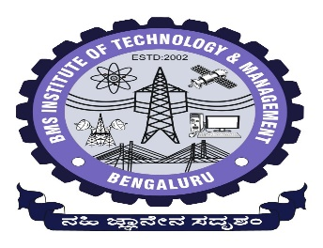

**BMS INSTITUTE OF TECHNOLOGY AND MANAGEMENT**

**(An Autonomous Institution, affiliated to VTU)**

Avalahalli Post, Doddaballapura Main Road, Yelahanka, Bangalore-560064

Department of MCA

**Consolidated Final Year Project Abstract (2023-2024)**

|  |  |
| --- | --- |
| **Project Title** | Digitalization of the MCA Department |
| **Name & USN** | Name: Shashank Katti  USN: 1BY22MC047 |
| **Email ID of Student (Gmail id)** | [shashankkatti32@gmail.com](mailto:shashankkatti32@gmail.com) |
| **Contact No. (Working number)** | 6363988040 |
| **Student Photo (Passport size with white background, face should be clearly visible)** |  |
| **Internal Guide Name** | Dr. Shivakumara T |
| **Project Area** | Web Development |
| **Abstract** | |
| The digitalization of the MCA Department involves the comprehensive integration of hardware and software systems to enhance operational efficiency and user experience. This initiative necessitates the deployment of standard desktops or laptops equipped with modern multicore processors and sufficient RAM, compatible with major operating systems and web browsers. These hardware components ensure a stable platform for accessing the newly developed application, facilitating seamless interaction and data management within the department. On the software front, the project employs a robust stack of technologies tailored to meet the complex demands of Digitalization of MCA Departments  Keywords: Hardware, Software, Desktops, Laptops, Multicore Processors, RAM, Operating Systems, Web Browsers, HTML5, CSS3, Django, Python, SQL LITE Database Management System, Digitalization | |